Media contact:
Nancy Kasten, NATP marketing and communications director
nkasten@natptax.com
800-558-3402, ext. 1172

Samantha Strong, NATP public relations and digital content manager
sstrong@natptax.com
800-558-3402, ext. 1178

Enhanced child tax credit benefits no longer applicable for 2022 returns
Taxpayers may see reduced refund compared to 2021 returns
APPLETON, Wis. (Jan. 1, 2023) – Taxpayers with children will see many changes in their tax situation on their 2022 tax return – some financially beneficial while most are not.
For 2021, the child tax credit was $3,600 for each qualifying child younger than 6, and $3,000 for each qualifying child ages 6 to 17. In addition, it was fully refundable even if taxpayers had no earned income or no tax liability. In other words, the credit reduced the tax amount due and if the credit amount exceeded the tax due, the excess was fully refundable.
The child tax credit is significantly decreased for 2022. It returns to $2,000 for each qualifying child under age 17 and begins phasing out when the taxpayer’s modified adjusted gross income exceeds $400,000 for a married filing joint return, or $200,000 for any other filing status.
In addition, the credit is no longer fully refundable. The refundable portion is limited to 15% of the taxpayer's earned income more than $2,500, or 15% of the earned income over $2,500, and it’s capped at $1,500 per child. This generally isn’t an issue if the child tax credit is less than the taxpayer’s tax liability because the credit is allowed in full. However, when the credit exceeds the tax due, whether any portion of the excess is refundable depends on the earned income limit.
For 2021, certain taxpayers also received advance child tax credit payments in monthly installments between July 1 and Dec. 31, 2021, which had to be reconciled on their 2021 tax return. Sometimes this unexpectedly resulted in additional tax due depending on the taxpayer’s circumstances. No advance payments were made in 2022, so this won’t be an issue when filing 2022 tax returns.
The National Association of Tax Professionals (NATP) advises working with a trusted expert who keeps current on tax law changes and is an NATP member. To learn about NATP, or to find a local, registered tax professional, visit natptax.com.
###
About NATP: The National Association of Tax Professionals (NATP) is the largest association dedicated to equipping tax professionals with the resources, connections and education they need to provide the highest level of service to their clients. 23,000 members rely on NATP to deliver professional connections, content expertise and advocacy that provides them with the support they need to best serve their clients. The NATP headquarters is in Appleton, Wis. To learn more, visit www.natptax.com.

Media contact:
Nancy Kasten, NATP marketing and communications director
nkasten@natptax.com
800-558-3402, ext. 1172

Samantha Strong, NATP public relations and digital content manager
sstrong@natptax.com
800-558-3402, ext. 1178

Taxpayers with children will notice significant changes from 2021 on their 2022 returns
2022 returns include fewer credits, deductions, leading to smaller refund for some
APPLETON, Wis. (Jan. 1, 2023) – Families with dependents may see smaller refunds in 2022 because the 2021 tax law changes that expanded child-related credits have now expired. For instance, the 2021 child and dependent care credit increased to $8,000 for one child. In 2022, the credit reverts to 2020 levels (inflation-adjusted), and the dollar limit for eligible expenses is $3,000 for one qualifying individual or $6,000 for two or more.
For taxpayers with AGI of $15,000 or less, the credit is 35% of employment-related expenses. The maximum credit dollar amount is $1,050 ($3,000 x .35) for one qualifying individual, or $2,100 ($6,000 x .35) for two or more. The credit is reduced by one percentage for each $2,000 of AGI or fraction thereof above $15,000 through $43,000. Taxpayers with AGI over $43,000 are allowed a credit equal to 20% of employment-related expenses.
To receive the credit for child and dependent care expenses, the person receiving care must be either a dependent child under the age of 13 or someone who is physically or mentally incapable of caring for themselves, including the taxpayer’s spouse who is incapable of self-care. The taxpayer must also be the custodial guardian for the non-spouse qualifying person, and they must live with them more than half the year, even if they do not claim them as a dependent. The person being cared for must also have a valid Social Security number, ITIN or ATIN.
Only care provided while the taxpayer (and spouse, if applicable) is working or looking for work qualifies. Examples of care provided include nanny-share arrangements, day care, preschool and day camp. If married, taxpayers must file a joint return to claim the credit. Special rules apply for separated parents. Furthermore, they (and their spouse) must have earned income from wages, salaries, tips or net earnings from self-employment. The amount of expenses that can be used to calculate the credit cannot exceed earned income, and, if married, must be based on the lesser of the spouses’ earned incomes. A spouse who is a student for at least five months of the year is deemed to have earned income of $250 (one qualifying person) or $500 (two or more) for any one month they are a full-time student.
A qualified caregiver must provide the dependent care to be eligible for the credit. Spouses, the other parent of the taxpayer’s child, taxpayer’s dependents and the taxpayer’s children under age 19 are not qualified caregivers; however, a relative who is not the taxpayer’s dependent may qualify for the credit, even if the relative resides in the taxpayer’s home. At the end of the year, caregivers (including nonworking spouses if caring for someone who cannot care for themselves), should provide a statement with their federal employer ID number (EIN) or Social Security number (SSN), full name, address and amount paid.
If the taxpayer’s employer provides a dependent care benefit, the benefit amount reduces the amount of credit available on the tax return. Employers may now exclude $2,500 for single filers, or $5000 for married filing jointly taxpayers, from an employee’s income through a dependent care assistance program. If they pay someone to come to their home and provide care, they may be considered a household employer, in which case additional forms need to be included with the tax return.
The National Association of Tax Professionals (NATP) advises working with a trusted expert who keeps current on tax law changes and is an NATP member. To learn about NATP, or to find a local, registered tax professional, visit natptax.com.
###
About NATP: The National Association of Tax Professionals (NATP) is the largest association dedicated to equipping tax professionals with the resources, connections and education they need to provide the highest level of service to their clients. 23,000 members rely on NATP to deliver professional connections, content expertise and advocacy that provides them with the support they need to best serve their clients. The NATP headquarters is in Appleton, Wis. To learn more, visit www.natptax.com.

Media contact:
Nancy Kasten, NATP marketing and communications director
nkasten@natptax.com
800-558-3402, ext. 1172

Samantha Strong, NATP public relations and digital content manager
sstrong@natptax.com
800-558-3402, ext. 1178

U.S. taxpayers see more benefits in 2023 for improving homes to be more energy efficient
Inflation Reduction Act of 2022 extends and enhances tax credits to incentivize homeowners to make clean energy improvements through 2034
APPLETON, Wis. (Jan. 1, 2023) – U.S. homeowners can take advantage of the new and enhanced clean energy tax credits included in the Inflation Reduction Act, passed in August 2022, as early as Jan. 1, 2023, when they make qualifying home improvements.
The residential clean energy credit (formally known as the residential energy efficient property credit) was extended for purchasing solar water heating systems, solar panels, small wind energy components, geothermal heat pumps and batteries that store the electricity generated. It also includes the costs of onsite preparation, assembly and installation. The credit is 30% of the costs for tax years 2022 to 2032, 26% for tax year 2033, and 22% for 2034.
The credit is nonrefundable, meaning it will only offset tax. Any unused credits can be carried forward indefinitely until the taxpayer can use them to offset tax in a future year(s). In cases where the property is installed in connection with mixed-use property and the business use percentage is 20% or more, an allocation of the credit must be made between personal and business use.
The nonrefundable energy-efficient home improvement credit (formerly known as the nonbusiness energy property credit) saw several enhancements. Instead of a $500 lifetime limitation that applies before 2023, taxpayers are allowed an annual credit of $1,200 for the cost of qualifying property.
While there is an overall limitation of $1,200 per year, exterior windows and skylights are further limited to $600 per year for the aggregate cost of those items. Exterior doors are limited to a credit of $250 per door and the total credit related to exterior doors for the year cannot exceed $500. The Inflation Reduction Act removed the costs for metal and asphalt roofs designed to reduce heat gain. The building envelope components listed above must be installed in or on a dwelling unit that is the taxpayer’s principal residence in the U.S.
The annual limitation for certain heat pumps, heat pump water heaters, and biomass stoves and boilers cannot exceed $2,000. In addition, the credit for qualified energy property that meets certain energy efficiency requirements is limited to $600 per item. Qualified energy property includes central air conditioners, water heaters, furnaces and hot water boilers that use natural gas, propane or oil.
Any costs to improve or replace a panel board, subpanel board, branch circuit or feeder with a maximum load capacity of not less than 200 amps and that is part of the installation of either building envelope components or qualified energy property are included. Qualified energy property must be new and may be installed on the taxpayer’s principal residence or a vacation home as long as the home is located in the U.S. and used as a residence by the taxpayer.
This article contains general information for taxpayers. Each tax situation is different, so do not rely on this information as the sole source of authority.
The National Association of Tax Professionals (NATP) advises working with a trusted expert who keeps current on tax law changes and is an NATP member. To learn about NATP, or to find a local, registered tax professional, visit natptax.com.
###
About NATP: The National Association of Tax Professionals (NATP) is the largest association dedicated to equipping tax professionals with the resources, connections and education they need to provide the highest level of service to their clients. 23,000 members rely on NATP to deliver professional connections, content expertise and advocacy that provides them with the support they need to best serve their clients. The NATP headquarters is in Appleton, Wis. To learn more, visit www.natptax.com.

Media contact:
Nancy Kasten, NATP marketing and communications director
nkasten@natptax.com
800-558-3402, ext. 1172

Samantha Strong, NATP public relations and digital content manager
sstrong@natptax.com
800-558-3402, ext. 1178

Beneficiaries must take minimum distributions from inherited IRAs in specific timeframe to avoid penalties
Increase in taxpayers inheriting retirement plans in recent years
APPLETON, Wis. (Jan. 1, 2023) – In general, taxpayers must begin to take required minimum distributions (RMDs) each year from their IRA, SEP IRA, SIMPLE IRA or other qualified retirement plan when they reach a specific age:
If taxpayer reaches age: | Start RMDs after reaching age:
70-and-a-half 2020 | 70-and-a-half
70-and-a-half after 2019, and 72 before 2023 | 72
72 after 2022, and 73 before 2033 | 73
74 after 2032 | 75

When a taxpayer inherits an IRA, the RMD rules for a beneficiary depend on several factors, such as their relationship to the deceased IRA owner and whether the IRA owner already started taking RMDs.
For IRA owners dying after 2019, nonspouse designated beneficiaries generally must distribute the entire IRA within 10 years following the year of death, whether the IRA owner died before or after starting RMDs (10-year rule). However, if the beneficiary is an eligible designated beneficiary (EDB), RMDs may be stretched out over a longer period.
An EDB is a designated beneficiary who is disabled, chronically ill, not more than 10 years younger than the IRA owner, a child of the IRA owner who has not reached the age of majority, or a surviving spouse of the IRA owner. In general, the following rules apply to EDBs:
- If the IRA owner died before they were required to start taking distributions, an EDB must take annual RMDs over the beneficiary’s remaining life expectancy, unless they elect the 10-year rule. In general, RMDs must begin by Dec. 31 of the year following the year of death. However, if the surviving spouse is the sole beneficiary, they can wait until Dec. 31 of the year the IRA owner would have reached the age to start RMDs.
- If the IRA owner died after starting RMDs, an EDB must continue to take annual RMDs over the longer of the beneficiary’s remaining life expectancy or the IRA owner’s remaining life expectancy.
- If a surviving spouse is the sole beneficiary, they can elect to treat the IRA as their own and then follow the RMD rules for IRA owners.
Lastly, if the IRA doesn’t have a designated beneficiary (or the IRA owner’s estate is the named beneficiary), different rules apply. If the IRA owner died before they were required to start taking distributions, the entire IRA must be distributed by the end of the fifth year following the year of death. On the other hand, if the IRA owner died after starting RMDs, RMDs must continue to be taken over the IRA owner’s remaining life expectancy.
This article contains general information for taxpayers. Each tax situation is different, so do not rely on this information as the sole source of authority.
The National Association of Tax Professionals (NATP) advises working with a trusted expert who keeps current on tax law changes and is an NATP member. To learn about NATP, or to find a local, registered tax professional, visit natptax.com.
###
About NATP: The National Association of Tax Professionals (NATP) is the largest association dedicated to equipping tax professionals with the resources, connections and education they need to provide the highest level of service to their clients. 23,000 members rely on NATP to deliver professional connections, content expertise and advocacy that provides them with the support they need to best serve their clients. The NATP headquarters is in Appleton, Wis. To learn more, visit www.natptax.com.

Media contact:
Nancy Kasten, NATP marketing and communications director
nkasten@natptax.com
800-558-3402, ext. 1172

Samantha Strong, NATP public relations and digital content manager
sstrong@natptax.com
800-558-3402, ext. 1178

Electric vehicles tax credit for 2022 and 2023
Inflation Reduction Act expanded the electric vehicle credit, but added additional requirements
APPLETON, Wis. (Jan. 1, 2023) – Some drivers looking to purchase an electric vehicle in 2023 can still take advantage of a federal tax credit when it comes time to prepare their 2023 returns, but buyers will need to satisfy more conditions than in previous years. The Inflation Reduction Act of 2022 expanded and modified the current electric vehicle tax credit’s stipulations to include more makes and models, as well as used electric vehicles. However, it also limited the tax credit to vehicles under a specified retail price, added North American sourcing requirements, and limited the credit to taxpayers earning less than a specified amount. Some electric vehicles purchased and delivered in 2022 were also impacted by this legislation.
The clean vehicle credit, which replaces the qualified plug-in electric drive motor vehicle credit, can be claimed for the purchase of a qualified vehicle beginning in 2023 through 2032. The maximum credit is $7,500 for buyers of new all-electric vehicles and hybrid plug-ins. To qualify for the credit, the vehicle must be sold after Aug. 16, 2022, the final assembly of the vehicle must be in North America and the manufacturer must meet the battery and critical mineral components requirement. The per-manufacturer cap is eliminated. Before this new legislation, the credit began to phase out for a manufacturer when that manufacturer sold 200,000 qualified vehicles.
For taxpayers who entered into binding contracts between Jan. 1, 2022, and Aug. 16, 2022, a transition rule applies. If a taxpayer purchased a vehicle before Aug. 16, 2022, the qualified plug-in electric drive motor vehicle (“old”) rules applied. For taxpayers who had written binding contracts in place before Aug. 16, 2022, but took possession after Aug. 16, 2022, the old rules also apply, and the new final assembly rules do not apply. For those who purchased and took possession of the vehicle on or after Aug. 16, 2022, but before Jan. 1, 2023, the old rules applied, including manufacturing caps, but the new final assembly rules also apply.
The legislation also includes a new credit for previously owned clean vehicles. To claim this credit, a qualified buyer must purchase and place in service a previously owned clean vehicle after 2022. The credit amount is the lower of $4,000 or 30% of the cost of the vehicle.
The act also added a new credit for qualified commercial clean vehicles. This credit is for qualifying commercial use clean vehicles acquired after Dec. 31, 2022.
There are several details that have yet to be announced by the IRS, including when and how the tax credit will be given to buyers, but more information will likely be made available as 2023 progresses.
This article contains general information for taxpayers. Each tax situation is different, so do not rely on this information as the sole source of authority.
The National Association of Tax Professionals (NATP) advises working with a trusted expert who keeps current on tax law changes and is an NATP member. To learn about NATP, or to find a local, registered tax professional, visit natptax.com.
###
About NATP: The National Association of Tax Professionals (NATP) is the largest association dedicated to equipping tax professionals with the resources, connections and education they need to provide the highest level of service to their clients. 23,000 members rely on NATP to deliver professional connections, content expertise and advocacy that provides them with the support they need to best serve their clients. The NATP headquarters is in Appleton, Wis. To learn more, visit www.natptax.com.

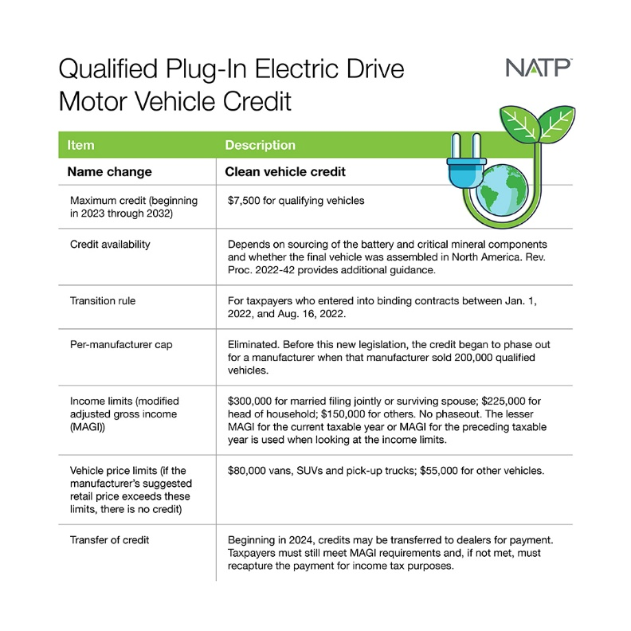
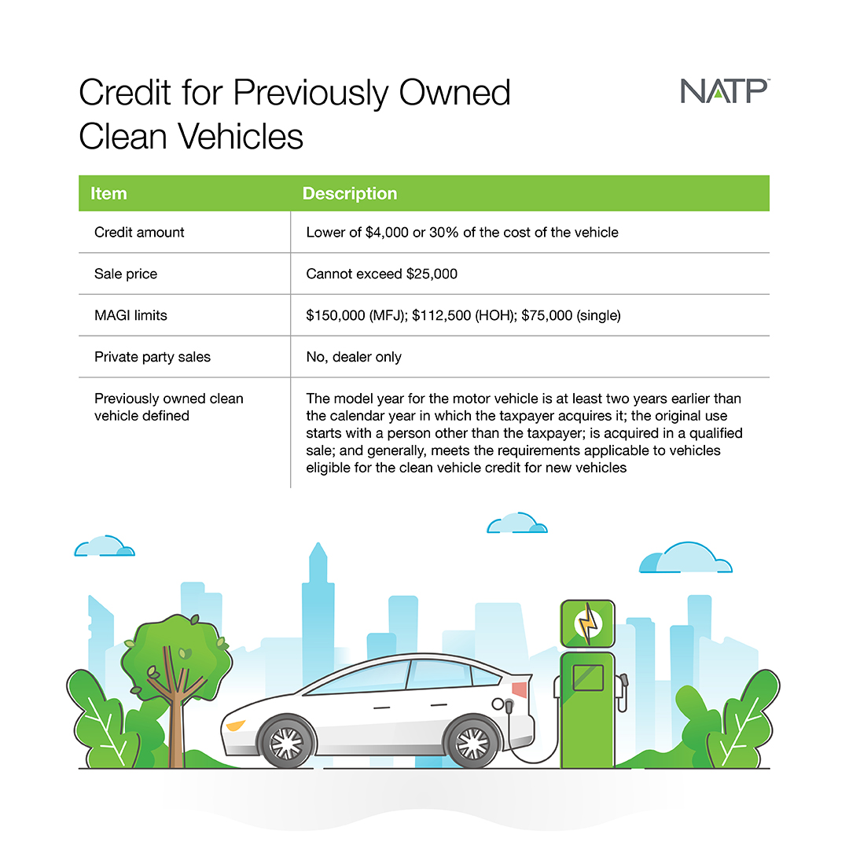
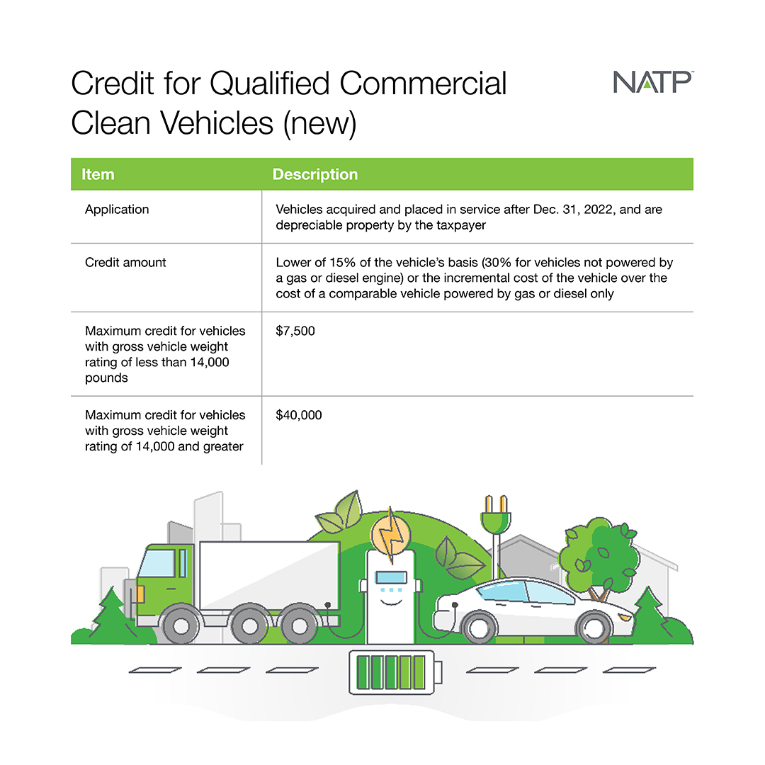
Media contact:
Nancy Kasten, NATP marketing and communications director
nkasten@natptax.com
800-558-3402, ext. 1172

Samantha Strong, NATP public relations and digital content manager
sstrong@natptax.com
800-558-3402, ext. 1178

Federal tax implications of Biden’s student loan debt forgiveness plan remain unchanged
Millions of taxpayers with student loan debt in limbo as plan’s constitutionality is challenged in federal court
APPLETON, Wis. (Jan. 1, 2023) – President Biden’s plan to forgive billions of dollars in federal student loan debt is on hold due to federal court challenges, but any changes to the plan resulting from litigation will not change the tax impacts to those who were already approved for forgiveness. Legislation passed by Congress in 2021 prevents the IRS from treating any forgiven student loan debt as income, regardless of how the forgiveness comes about, through 2025.
Congress foresaw the impact student loan forgiveness could have on those individuals who had their debt forgiven and included a provision in the March 2021 American Rescue Plan Act specifying that most student loan forgiveness received before the end of 2025 will not be taxable as income. Traditionally, all forgiven debt, unless excluded under the tax code, is treated as income. While some states have chosen to follow Congress’s lead on the taxation of student loan forgiveness, others have either not addressed the issue or have specifically said the amount forgiven will be subject to state income tax.
In August 2022, President Biden announced a plan that would forgive $10,000 ($20,000 for Pell Grants) in undergraduate student loan debt for individuals earning less than $125,000 ($250,000 for married couples). The White House has maintained that it is allowed to grant this relief under the Heroes Act of 2003, which lets the secretary of education waive student loan regulations during times of war or national emergency. The U.S. has been operating under a pandemic emergency declaration since it was declared in 2020 by former-President Trump.
Borrowers have been able to skip their student loan payments under COVID-19 relief provisions that began in 2020. These provisions have been extended several times by both former-President Trump and President Biden. In light of the pending litigation, the latest extension, announced Dec. 13, 2022, pushed the date to June 2023.
To date, the government has received almost 26 million applications from borrowers seeking to have their student loan debt forgiven and has approved millions of applications. However, legal challenges to the plan have prevented any debt from being cancelled. Two federal court challenges to the debt forgiveness program have barred the government from moving forward with the plan.
The first injunction was issued by the U.S. Court of Appeals for the 8th Circuit in November at the request of six states that claim the proposal exceeds President Biden’s executive authority and deprive them of future tax revenue. The second injunction was issued by a Texas federal judge who found the forgiveness program to violate federal law because the Biden administration did not follow procedures allowing for public comment before announcing the program. The U.S. Supreme Court announced it will hear arguments on challenges to the program in February 2023.
Regardless of the final decision to forgive any amount of student loan debt, most taxpayers will not be forced to include specified forgiven student loan debt in their income at the federal level.
This article contains general information for taxpayers. Each tax situation is different, so do not rely on this information as the sole source of authority.
The National Association of Tax Professionals (NATP) advises working with a trusted expert who keeps current on tax law changes and is an NATP member. To learn about NATP, or to find a local, registered tax professional, visit natptax.com.
###
About NATP: The National Association of Tax Professionals (NATP) is the largest association dedicated to equipping tax professionals with the resources, connections and education they need to provide the highest level of service to their clients. 23,000 members rely on NATP to deliver professional connections, content expertise and advocacy that provides them with the support they need to best serve their clients. The NATP headquarters is in Appleton, Wis. To learn more, visit www.natptax.com.

Media contact:
Samantha Strong, NATP public relations and digital content manager
sstrong@natptax.com
800-558-3402, ext. 1178

Nancy Kasten, NATP marketing and communications director
nkasten@natptax.com
800-558-3402, ext. 1172

Incorrect, missing Social Security numbers top list of most common tax mistakes
Rejected returns can delay refund several weeks, months
APPLETON, Wis. (Jan. 1, 2023) – At the close of each tax filing season, the IRS compiles a list of the most common errors taxpayers make when filing their tax returns. Frequent culprits in recent years include missing or incorrect Social Security numbers, incorrectly entered information and math mistakes.
When an incorrect return is filed, the IRS first rejects it, then it will often send the taxpayer a notice requesting additional information. This can delay a refund by several weeks, or even months. In other instances, the IRS may issue a refund, but for a smaller amount than the taxpayer was expecting. This may occur when, for example, the taxpayer claims more of their income was withheld than what their employer reported on their Form W-2.
Another common filing mistake made by individual taxpayers is failing to provide the Social Security number or taxpayer identification number of the caregiver when the taxpayer is claiming the child and dependent care credits. This costly error causes the IRS to issue the refund, but it will be reduced by the amount of the credit claimed by the taxpayer. Filing an amended return to correct the error will leave the taxpayer waiting weeks to be refunded the credit amount. Likewise, omitting the Social Security number, ITIN or ATIN of a qualifying child for any of the child-related credits will slow or disqualify the credit claim.
Other common mistakes to avoid when filing taxes this year include:
- Filing too early. Filing before all relevant tax documents are available risks mistakes that lead to processing delays. Jan. 31 is the deadline for issuers to mail W-2s and 1099-NECs, so waiting until February could eliminate a processing delay.
- Entering information inaccurately. Misspelled names, math errors and wrong bank account numbers slow down processing. Double check input and use direct deposit for refunds.
- Math errors. These are among the most common mistakes and can range from simple errors of addition and subtraction to mistakes in the use of complex calculations.
- Using an incorrect filing status. The Interactive Tax Assistant on IRS.gov helps taxpayers choose the correct status. Additionally, experienced tax professionals can help taxpayers determine the best status based on personal and financial information.
- Mistakes in calculating credits or deductions. Taxpayers often make errors in calculating such things as the earned income tax credit, child and dependent care credit, child tax credit and recovery rebate credit.
- Incorrect bank account numbers for direct deposit. Direct deposit is the fastest way for taxpayers to get their refunds, but mistakes in reporting their account or routing number can cause your refund to be delayed.
- Forgetting to sign forms. An unsigned tax return isn’t valid. In most cases, both spouses must sign a joint return. Exceptions apply for some members of the armed forces or taxpayers with a valid power of attorney.

The IRS compiles income, payment and other information in each taxpayer’s account. Differences between what taxpayers report and what is in the account lead to processing delays. Taxpayers can create an IRS online personal account to access the data the IRS has on file. Use interactive assistant tools on the IRS website to calculate eligibility. Save IRS notifications received in the mail. The IRS encourages taxpayers to e-file and use direct deposit for refunds.
The National Association of Tax Professionals (NATP) advises working with a trusted expert who keeps current on tax law changes and is an NATP member. To learn about NATP, or to find a local, registered tax professional, visit natptax.com.
###
About NATP: The National Association of Tax Professionals (NATP) is the largest association dedicated to equipping tax professionals with the resources, connections and education they need to provide the highest level of service to their clients. 23,000 members rely on NATP to deliver professional connections, content expertise and advocacy that provides them with the support they need to best serve their clients. The NATP headquarters is in Appleton, Wis. To learn more, visit www.natptax.com.

Media contact:
Samantha Strong, NATP public relations and digital content manager
sstrong@natptax.com
800-558-3402, ext. 1178

Nancy Kasten, NATP marketing and communications director
nkasten@natptax.com
800-558-3402, ext. 1172

IRS filing deadline approaching for small, non-profit organizations
Deadline includes sports clubs, civic organizations and local associations
APPLETON, Wis. (Jan. 1, 2023) – Even small non-profit organizations, such as sports clubs, civic organizations and local associations, are required to file an annual information return with the IRS. The IRS then makes the reported information available for public inspection, allowing information about an organization’s sources of funds or project and administrative expenditures to shape donors’ choices.
By law, the IRS will automatically revoke the federal tax-exempt status of organizations that don’t file annual reports for three consecutive years. However, churches and church-related organizations are not required to file annual reports unless they have unrelated business taxable income (UBTI).
The Form 990-series information returns and electronic notices are due on the 15th day of the fifth month after an organization’s tax year ends. If the due date falls on a Saturday, Sunday or a legal holiday, the due date is the next business day. Many organizations use the calendar year as their tax year, making May 15, 2023, the deadline to file their information returns for 2022.
The IRS offers an online search tool called Tax Exempt Organization Search. This helps users easily find key information about the federal tax status and filings of certain tax-exempt organizations, including whether an organization had its federal tax exemption automatically revoked.
The National Association of Tax Professionals (NATP) advises working with a trusted expert who keeps current on tax law changes and is an NATP member. To learn about NATP, or to find a local, registered tax professional, visit natptax.com.
###
About NATP: The National Association of Tax Professionals (NATP) is the largest association dedicated to equipping tax professionals with the resources, connections and education they need to provide the highest level of service to their clients. 23,000 members rely on NATP to deliver professional connections, content expertise and advocacy that provides them with the support they need to best serve their clients. The NATP headquarters is in Appleton, Wis. To learn more, visit www.natptax.com.

Media contact:
Nancy Kasten, NATP marketing and communications director
nkasten@natptax.com
800-558-3402, ext. 1172

Samantha Strong, NATP public relations and digital content manager
sstrong@natptax.com
800-558-3402, ext. 1178

Taxpayers must take more steps to deduct charitable contributions on 2022 returns
Certain donations are not recognized by the IRS as deductible
APPLETON, Wis. (Jan. 1, 2023) – For 2022, taxpayers can only deduct a charitable contribution if they itemize their deductions and don't claim the standard deduction. As part of its COVID-19 response the IRS implemented a one-year change that allowed taxpayers who claimed the standard deduction to deduct up to $300 of their charitable contributions ($600 for married taxpayers filing jointly) for the 2021 tax year.
A qualified charitable contribution includes cash contributions to churches, nonprofit educational institutions, nonprofit medical institutions, public charities or other qualified charities. AGI limitations that were suspended in 2020 and 2021 also revert back to the pre-COVID levels of 60% of an individual’s contribution base, for most cash contributions.
Before donating, it is wise to verify the organization’s charitable status by calling, checking their website or using the IRS’s tax-exempt organization search. The IRS cautions users that data update delays now exist, limiting the database’s accuracy. A bank record supporting the donation or written receipt from the charity showing the name of the donee organization, date and amount of contribution is needed for any deductible donation – even a single dollar dropped into the red bucket.
For those who do itemize, not every donation is deductible. For example, clothing or food given directly to victims of a disaster (through a charity), political contributions and time volunteering — even if the work accomplishes something a paid position would otherwise accomplish, or if time was taken off work — are all considered nondeductible contributions.
Contributions are commonly paid via cash check, credit card or payroll deductions. The entire amount of a monetary donation is deductible if nothing of value is received in return. If a benefit is received because of a contribution, only the part of the contribution that is greater than the value of what was received is deductible.
Other common donations are out-of-pocket expenses paid to do volunteer work or property donations. If transportation costs to perform volunteer work are incurred, the actual cost of gas and oil, parking and tolls, or the standard rate of 14-cents-per-mile (2022) can be deducted. Volunteers must keep detailed records of any out-of-pocket expenses incurred. To value clothing and household items, use their fair market value (FMV) and deduct donated food items at cost.
Noncash contributions require records describing the property donated and the method used to determine its value. The taxpayer is responsible for valuing the property either through appraisal or by comparison to other property. Generally, charitable organizations will only issue a receipt stating the donation was made and will not assign a value. Special rules apply for donated stock, real estate and other capital assets that would have resulted in capital gains. The applicable guidance for property contributions of more than $500, and property contributions of more than $5,000, should be consulted when applicable.
The National Association of Tax Professionals (NATP) advises working with a trusted expert who keeps current on tax law changes and is an NATP member. To learn about NATP, or to find a local, registered tax professional, visit natptax.com.
###
About NATP: The National Association of Tax Professionals (NATP) is the largest association dedicated to equipping tax professionals with the resources, connections and education they need to provide the highest level of service to their clients. 23,000 members rely on NATP to deliver professional connections, content expertise and advocacy that provides them with the support they need to best serve their clients. The NATP headquarters is in Appleton, Wis. To learn more, visit www.natptax.com.

Media contact:
Nancy Kasten, NATP marketing and communications director
nkasten@natptax.com
800-558-3402, ext. 1172

Samantha Strong, NATP public relations and digital content manager
sstrong@natptax.com
800-558-3402, ext. 1178

Some employers can still amend their returns to claim the employee retention credit
Per-employee credit was offered to employers to retain employees during the pandemic
APPLETON, Wis. (Jan. 1, 2023) – Businesses can no longer claim the employee retention tax credit (ERC) of up to $7,000 per quarter, per employee, to help pay their employees’ wages. However, employers that did not claim the ERC when it was offered can still amend their previously filed returns to take advantage of it. Employers who filed Form 941, Employer’s Quarterly Tax Return, in 2020 and 2021 have until the end of 2024 and 2025, respectively, to file amended returns that retroactively claim the credit.
The ERC is a refundable tax credit businesses can claim on qualified wages, including certain health insurance costs, paid to employees. When a credit is refundable, the taxpayer is entitled to the full amount of the credit, even if it exceeds the tax owed.
The ERC was enacted in 2020 when many businesses were struggling with the economic fallout of the COVID-19 pandemic and applies to the first three quarters in 2021, unless the business is a recovery start-up business. Generally, the maximum credit for 2020 is $5,000 per employee, and was increased to $7,000 per quarter per employee in 2021.
Who is eligible for the ETC?
An employer can use three methods to determine their eligibility for the credit. The first is a decline in gross receipts. For 2020, the requirement is a 50% decline of the gross receipts compared to the same quarter in 2019. For 2021, gross receipts would be less than 80% when compared to the same quarter in 2019.
Alternatively, the taxpayer can be eligible under the gross receipts test by comparing the gross receipts of the immediately preceding quarter to the corresponding quarter in 2019. The taxpayer can substitute 2020 for 2019 if they did not exist as of the beginning of that quarter in 2019.
The second qualifying scenario is if a business had a full or partial suspension of business due to orders from a government authority limiting commerce, travel or group meetings due to COVID-19. To qualify, the suspension must have a more than nominal effect on the business due to the facts and circumstances.
A nominal effect is defined by either the gross receipts from that portion of business operations was not less than 10% of total gross receipts (both determined using the gross receipts of the same calendar quarter in 2019), or the hours of service performed by employees in that portion of the business was not less than 10% of the total number of hours of service performed by all employees in the employer's business (compared to the same quarter in 2019).
The third qualifying scenario is if the business qualifies as a recovery start-up business. The business must have begun operations after Feb. 15, 2020, with annual average gross receipts of no more than $1 million. The maximum credit is $50,000 per quarter for the third and fourth quarter of 2021.
Filing an amended return to claim the ERC
A taxpayer can still claim the ERC by filing Form 941-X, Adjusted Employer's Quarterly Federal Tax Return or Claim for Refund, for each quarter they are eligible to claim the credits. When claiming credits for 2020, the amended returns are due by April 15, 2024, and April 15, 2025, for 2021. Once a business claims the ERC, they must amend their business return for the period claimed from 2020 or 2021 and reduce their wage expense by the amount of the credit.
This article contains general information for taxpayers. Each tax situation is different, so do not rely on this information as the sole source of authority.
The National Association of Tax Professionals (NATP) advises working with a trusted expert who keeps current on tax law changes and is an NATP member. To learn about NATP, or to find a local, registered tax professional, visit natptax.com.
###
About NATP: The National Association of Tax Professionals (NATP) is the largest association dedicated to equipping tax professionals with the resources, connections and education they need to provide the highest level of service to their clients. 23,000 members rely on NATP to deliver professional connections, content expertise and advocacy that provides them with the support they need to best serve their clients. The NATP headquarters is in Appleton, Wis. To learn more, visit www.natptax.com.

Media contact:
Samantha Strong, NATP public relations and digital content manager
sstrong@natptax.com
800-558-3402, ext. 1178

Nancy Kasten, NATP marketing and communications director
nkasten@natptax.com
800-558-3402, ext. 1172

Taxpayers, tax pros are warned of fake IRS scams
Scammers send fake IRS notices, lure unsuspecting victims
APPLETON, Wis. (Jan. 1, 2023) – Every year, taxpayers are bombarded with texts, emails and letters claiming to be from the IRS and asking for personal information. The subject line on many of these emails claims the IRS is trying to contact the person because they have a refund for them. These are commonly referred to as phishing scams.
Phishing is a term used to describe texts and emails that are “fishing for information” and “hooking” victims. The goal is to “lure” readers into believing the IRS needs information from them.
Do not reply to these phishing emails. Do not open any attachments — they might contain malicious code that could infect the computer. Also, do not click any links provided in the email. Fraudsters typically request bank information or credit card numbers so recipients can pay their tax due or receive their refunds. Unsuspecting persons then become victims of identity theft.
Ghost preparers are also on the rise, which is dangerous for taxpayers who are unaware of the repercussions of using one. A ghost preparer is someone who doesn’t include identifying information or sign the tax returns they prepare, making it extremely difficult to locate them and hold them liable if errors are discovered on the return.
Paid preparers are required to sign the returns they submit and a preparer who does not sign a return or provide any identifying information should raise a red flag for taxpayers. Ghost preparers are often looking to make a quick profit by promising a big refund or charging fees based on the size of the refund. The preparer then disappears after filing the return, leaving no evidence they prepared the return and the taxpayer liable for any inaccuracies or possible criminal fallout.
Additionally, COVID scammers will sometimes use taxpayers’ stolen identities and Social Security numbers to file fraudulent unemployment claims. When that happens, the state paying the claim will submit a Form 1099-G to the IRS reporting that the victim received the income, even if it was paid to the scammers.
As a result, the IRS may try to tax income the victim never received based on the Form 1099-G. Fraudsters will also notify individuals that their Social Security number will be suspended or canceled, threatening legal action if the victim does not respond. Finally, criminals are faking calls from the Taxpayer Advocate Service to get frightened taxpayers to reveal personal data.
The IRS continues to issue warnings about the fraudulent use of the IRS name or logo by scammers trying to trick recipients into providing sensitive information that can be used to steal their identity and assets.
The IRS will never request financial information, passwords, PINs or any other sensitive information from anyone via text, email or social media. The IRS sends paper notices to discuss tax account information. Never provide banking information in response to unsolicited texts, emails or social media posts from accounts claiming to be the IRS.
The IRS will not call taxpayers threatening legal action. If you receive a call like this, hang up. Scammers now use fraudulent tax transcripts as bait to try to have documents opened containing malware or viruses. Taxpayers who suspect tax violations should report fraud to the IRS using Form 3949A or forward phishing emails to phishing@irs.gov.
The National Association of Tax Professionals (NATP) advises working with a trusted expert who keeps current on tax law changes and is an NATP member. To learn about NATP, or to find a local, registered tax professional, visit natptax.com.
###
About NATP: The National Association of Tax Professionals (NATP) is the largest association dedicated to equipping tax professionals with the resources, connections and education they need to provide the highest level of service to their clients. 23,000 members rely on NATP to deliver professional connections, content expertise and advocacy that provides them with the support they need to best serve their clients. The NATP headquarters is in Appleton, Wis. To learn more, visit www.natptax.com.

Media contact:
Nancy Kasten, NATP marketing and communications director
nkasten@natptax.com
800-558-3402, ext. 1172

Samantha Strong, NATP public relations and digital content manager
sstrong@natptax.com
800-558-3402, ext. 1178

Military personnel may receive additional tax benefits for 2022 returns
APPLETON, Wis. (Jan. 1, 2023) – Members of the military and their families may be eligible for special tax benefits on their 2022 tax returns. For federal tax purposes, the U.S. Armed Forces includes enlisted personnel in all regular and reserve units controlled by the Secretaries of Defense – the Air Force, Army, Coast Guard and Navy.
Travel expenses can be deducted if they are unreimbursed and are incurred while traveling away from home. Homes of U.S. Armed Forces members are considered their duty station if they are on a permanent duty assignment. To be deductible, the travel expenses must be work related. Military personnel cannot deduct any expenses for personal travel, such as visits to family on leave. If part of the reserves, unreimbursed travel expenses for traveling more than 100 miles from home to perform reserve duties are eligible for deduction. They do not have to itemize deductions since eligible expenses are deducted as an adjustment to income. The standard mileage rate is 56 cents for 2021 with a split rate in 2022, which is 58.5 cents Jan. 1, 2022, to June 30, 2022; and 62.5 cents from July 1, 2022, to Dec. 31, 2022.
Uniform purchase cost and future upkeep deductibility depend on whether the uniform can be worn when off duty. If the uniform can be worn while off duty, no costs can be deducted. However, if the uniform is prohibited from being worn when off duty, the cost associated with that uniform may be deducted. The following are deductible:
- Military battle dress uniforms and utility uniforms that cannot be worn while off-duty
- Articles not replacing regular clothing, including insignia of rank, corps devices, epaulets, aiguillettes and swords

Moving expenses have special rules that apply to active-duty members of the U.S. Armed Forces and their surviving spouses who move due to a permanent station change. Deductible expenses include unreimbursed costs of moving, travel and storing, and insuring personal items including household goods. For 2022, the standard mileage rate for moving is 18 center per mile Jan. 1, 2022, to June 20, 2022, and 22 cents per mile July 1, 2022, to Dec. 31, 2022.
Distributions from an IRA, 401(k) or 403(b) plans made after the date of the order or call to active duty and before the close of the active-duty period have special rules and may not be subject to the 10 percent penalty tax on early distributions. Such distributions are also eligible to be repaid to the plan if paid back within two years of ending active duty.
The National Association of Tax Professionals (NATP) advises working with a trusted expert who keeps current on tax law changes and is an NATP member. To learn about NATP, or to find a local, registered tax professional, visit natptax.com.
###
About NATP: The National Association of Tax Professionals (NATP) is the largest association dedicated to equipping tax professionals with the resources, connections and education they need to provide the highest level of service to their clients. 23,000 members rely on NATP to deliver professional connections, content expertise and advocacy that provides them with the support they need to best serve their clients. The NATP headquarters is in Appleton, Wis. To learn more, visit www.natptax.com.

Media contact:
Samantha Strong, NATP public relations and digital content manager
sstrong@natptax.com
800-558-3402, ext. 1178

Nancy Kasten, NATP marketing and communications director
nkasten@natptax.com
800-558-3402, ext. 1178

The importance of meeting with a qualified tax professional for 2022 returns
What to bring to the annual appointment

APPLETON, Wis. (Jan. 1, 2023) – Although tax season preparations have begun, it’s not too late to contact a qualified tax professional to complete and file a return. Tax returns can be done more quickly if the taxpayer provides all the information during the initial appointment.

Taxpayers should prepare for the tax appointment by compiling a list of documents they received based on last year’s tax return, statements, forms and this tax year’s activities. This year, taxpayers should also provide any 1099-K forms, Payment Card and Third Party Network Transactions, which will be sent to taxpayers who received more than $600 on various third-party payment platforms such as Venmo.

Taxpayers should contact a qualified tax preparer with any questions about necessary documents needed. When the documents are received (usually around the end of January), mark them off the list and put them in a tax folder to stay organized.

If employed, the taxpayer will need to include their W-2(s). If they received income from interest, dividends, pensions, self-employment, government payments (like unemployment) or the sale of property, they should receive a Form 1099. It is helpful to provide the actual statements to the preparer. Remember that not all forms look alike. Somewhere on the envelope, on the form or in the email, it must clearly state it is an important tax document.

Also, taxpayers should remember to include any Schedule K-1s they receive from a partnership, an S corporation, trust or an estate. If the taxpayer had income not reported on the forms listed above, make note for the tax preparer to include it. Finally, if the taxpayer made gifts to qualified charities or individuals, either up to or over the annual exclusion amount, details should be provided to the tax preparer.

If stock was sold during the year, the taxpayer should receive Form 1099-B that notes the gross proceeds. If the stock was received as a gift or inheritance, other means of determining the cost will be necessary. For every stock sold, provide the basis and acquisition date. Likewise, the trade or disposal of virtual currency or other digital assets could result in capital gain or loss. If exchanges don’t provide a Form 1099-B, the broker’s spreadsheet of transactions and a crypto tax reporting software service might be useful to get sales prices and cost basis.

If a taxpayer owns a home, they might be able to itemize deductions. Each year, provide the property tax payment and the mortgage interest statement. Medical expenses are deductible if they exceed 7.5 percent of the adjusted gross income (AGI). Applicable medical expenses include prescription drugs, doctor, dental, hospital bills, medical insurance premiums not paid on a pre-tax basis through the taxpayer’s employer, and mileage to and from the doctor’s office.

Charitable contributions are a good source of deductions. Qualified contributions include cash donations to qualifying charitable organizations. Other deductible contributions can be cash, property or out-of-pocket expenses paid to do volunteer work. If the taxpayer drove to and from the volunteer site, they can take the actual cost of gas and oil, or use the standard rate of 14 cents per mile. Parking fees and tolls incurred are deductible whether the standard mileage rate or actual expense method is used. The taxpayer will need to substantiate any donation they claim.

The National Association of Tax Professionals (NATP) advises working with a trusted expert who keeps current on tax law changes and is an NATP member. To learn about NATP, or to find a local, registered tax professional, visit natptax.com.

###
About NATP: The National Association of Tax Professionals (NATP) is the largest association dedicated to equipping tax professionals with the resources, connections and education they need to provide the highest level of service to their clients. 23,000 members rely on NATP to deliver professional connections, content expertise and advocacy that provides them with the support they need to best serve their clients. The NATP headquarters is in Appleton, Wis. To learn more, visit www.natptax.com.

Media contact:
Nancy Kasten, NATP marketing and communications director
nkasten@natptax.com
800-558-3402, ext. 1172

Samantha Strong, NATP public relations and digital content manager
sstrong@natptax.com
800-558-3402, ext. 1178

Gig economy workers may face tax implications for 2022 returns
NATP advises opening separate business bank account to track deductible expenses
APPLETON, Wis. (Jan. 1, 2023) – Picking up a second job to supplement household income is common – especially as many Americans deal with the fallout of COVID-19. Many choose to become gig economy workers who deliver on-demand food and groceries, or packages from online retailers. Others choose to become freelance writers and designers, media or content creators, and Instagram influencers. Some may not realize, depending on their activities, they may face tax implications of becoming a gig worker because they could be considered a sole proprietor of a business.
Conducting business as a sole proprietor is one of the simplest forms of operation. It’s easy to start a business operated as a sole proprietorship, and equally as easy to discontinue. The first step when starting a business is to open a separate business checking account. It will be easier to track the deductible expenses if they are not co-mingled with personal expenses. If the taxpayer incurred expenses prior to opening their business, they should keep them separate from current operating expenses since special tax treatment applies to startup expenses.
It is important to track the business mileage of a personal vehicle, as it may be deductible. If a self-employed taxpayer maintains an eligible office in their home, they can deduct the mileage for trips to and from their client’s place of business, between jobs, and to purchase supplies or deliver goods.
After tracking the business mileage, the deduction is calculated using one of two methods: the standard mileage rate or actual expenses. The standard mileage rate is calculated by multiplying business mileage by the IRS issued rate of $.585 for Jan. 1 to June 30, 2022, and $.625 for July 1 to Dec. 31, 2022. The actual expense method tracks actual expenses, such as the cost of gas, oil, insurance, repairs, maintenance, tires and depreciation. This method requires the taxpayer to keep very detailed expense records and allocate only the business portion of the costs to the business use of auto deduction.
The IRS allows self-employed taxpayers to claim a deduction for business use of the home if they meet certain requirements. They must use the home office regularly and exclusively:
- As the principal place of business for their trade or business
- As a place to meet with customers in the normal course of their trade or business
- In connection with their trade or business, if the location is in a separate structure that’s not attached to the dwelling unit
Similar to the auto deduction, compute the home office deduction using one of two methods: the simplified method or the traditional method. The simplified method allows taxpayers to deduct $5 per square foot, up to a maximum of 300 square feet or $1,500 in total, for their home office. The traditional method allows taxpayers to deduct a portion of their indirect costs such as mortgage interest, and all their direct costs, like painting or decorating the office walls.
The National Association of Tax Professionals (NATP) advises working with a trusted expert who keeps current on tax law changes and is an NATP member. To learn about NATP, or to find a local, registered tax professional, visit natptax.com.
###
About NATP: The National Association of Tax Professionals (NATP) is the largest association dedicated to equipping tax professionals with the resources, connections and education they need to provide the highest level of service to their clients. 23,000 members rely on NATP to deliver professional connections, content expertise and advocacy that provides them with the support they need to best serve their clients. The NATP headquarters is in Appleton, Wis. To learn more, visit www.natptax.com.

